Cache Clear User Guide

For Cache Clearance Tool v2.0

Published 22nd January 2019

**Contents**

Document Purpose 3

Overview 3

Important Information 3

What’s New in Version 2.0 4

Where to get the Cache Clearance Tool 4

System requirements 4

Operating systems 4

Other components 4

Using the Cache Clearance Tool 5

Further Information 11

Support 16

# Document Purpose

This document is intended to provide general guidance on the use of the Cache Clearance Tool.

The tool is designed to be simple to use and does not require the user to have administrative rights on the machine for it to work.

# Overview

Spine provides the infrastructure that enables increased patient safety, improved quality of healthcare, greater clinical effectiveness and better administrative efficiency.

When using Series 8 (Oberthur) Smartcards, the users machine can cache the certificates contained on the Smartcard for ease of access. This can cause a potential issue when the user renews their Smartcard in a machine other than their own as this cache may not be updated with the new Smartcard content. When an attempt to use the Smartcard in this machine, the certificates on the card and in the cache do not match and cause the error “There was a problem reading your Smartcard” to be presented to the user.

The Cache Clearance tool purges the cache and forces the Middleware to rebuild the cache by reading the Smartcard content again, this should remove this issue.

The tool is an aid to the end users to prevent unnecessary visits to RA’s and also to reduce the number of Series 8 cards being scrapped.

The cache clearance tool will only function on machines with the following conditions  
1. Oberthur Middleware (any version) is installed  
2. The Oberthur registry change has been applied. Automatic with SR5 and SR8 installations  
3. A Series 8 (Oberthur) Smartcard has been presented to a connected Smartcard Reader.

This tool is only for use with a combination of Series 8 Smartcards and Oberthur Middleware. The tool is not required for users with a Series 8 Smartcard operating in a GEM Middleware environment, nor is it required for users with a GEM Smartcard regardless of which middleware is installed in their machines.

# ****Important Information****

**The Cache Clearance Tool is only designed to clear the Oberthur Middleware cache on the user’s machine. It will not repair invalid content on the card. The tool attempts to validate the content of the Smartcard by looking for expected content before declaring the cache clearance successful. There may be occasions where the tool reports valid content, but for various reasons e.g. CMS has failed to renew successfully, the user still cannot authenticate. In these circumstances, the user will still need their card repairing by an RA to log into Spine.**

**Please be aware that if your Trust controls the running of executable files via policies, you may need to refer to your local ICT department to allow the program to run, or visit your RA to get the Smartcard repaired**

# What’s New in Version 2.0

The cache clearance tool now correctly accepts alpha numeric for passcode entry rather than just numeric PIN entry for unlocking the Smartcard prior to cache clearance.

Text updates to change all references of “Smart card” to Smartcard and “Pin code” to Passcode in the GUI.

# Where to get the Cache Clearance Tool

The Cache clearance tool can be downloaded from the DIR site at <http://nww.hscic.gov.uk/dir/downloads/>

# System requirements

The Cache Clearance Tool requires a Windows operating system from the list stated in the Operating Systems section of this document (other operating systems may work but are not warranted) and also the correct version of .NET.

## Operating systems

The following Windows operating systems are warranted for use:

* + - * Windows 7 SP1 (x86 and x64)
      * Windows 8.1 (x86 and x64)
      * Windows 10 (x64 only)

## Other components

|  |  |  |
| --- | --- | --- |
| Component | Description | Minimum Version |
| .NET Framework | The programming infrastructure created by Microsoft for building, deploying, and running applications and services that use .NETtechnologies. | Microsoft .NET 4.0.30319 or higher. There is no requirement to install .NET 3.5.1 |

# Using the Cache Clearance Tool

The cache clearance tool is downloaded from the DIR site at the location above in a .zip pack containing all the files needed to run the tool.

The tool requires no installation and will run directly from the location the files are unzipped to.

Step 1. Open Windows explorer at the location where you unzipped all the files that comprise the Cache Clearance Tool.

Step 2. Run/Execute OTCardCacheCleaner.exe. Admin rights are not required

Step 3. If the cache clearance tool shows a red Thumbs Down picture, the application has detected that there is a potential issue with the presented Smartcard. The user must then enter the Passcode for your Smartcard and click the “Clear Cache” button to attempt to clear the Middleware cache and validate the Smartcard content.

Step 4. Once the attempt to clear the cache has completed. If the tool now shows a green Thumbs Up picture, the Middleware cache has been successfully cleared and the content of the Smartcard appears as expected. You should now be able to authenticate with your Smartcard

Or

Step 4. If on completion of the attempt to clear the Middleware cache and validate the Smartcard content the tool still shows a red Thumbs Down picture, the tool has not been successful. The application has determined that the Smartcard is in an unreadable state and the user will still require a visit to their RA to diagnose the fault and/or obtain a functional Smartcard.  
  
Step 5. Now the application has completed its task, to exit you can either click the red X, or File / Exit to close the tool.

#### Initial Screen with no Cards Inserted

If no Series 8 Smartcard can be detected in an attached Smartcard Reader the application will present this screen by default. Notice that the Oberthur Middleware version is depicted in the status bar.

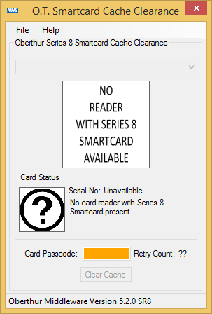

#### Suspected Faulty Card Inserted

If the Cache Clearance Tool is unable to validate the content of the Smartcard on the initial read, the user is given a red Thumbs Down picture advising that cache clearance may be required to rectify the issue.

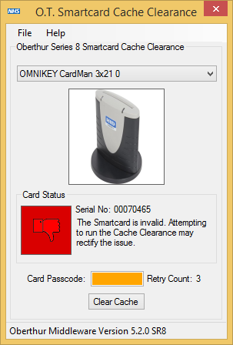

#### Cache Clearance Tool Working

After the user supplies the correct Passcode for their Smartcard and clicks the ‘Clear Cache’ button they will be presented with the following screen. Whilst the tool is attempting to clear the cache for the Smartcard, the Card Status window will change from a Thumbs Down to moving cogs indicating that the cache clearance is in the process of occurring. During this time to not remove the Smartcard from the reader as this may cause unexpected functionality in the application and could potentially damage the Smartcard.

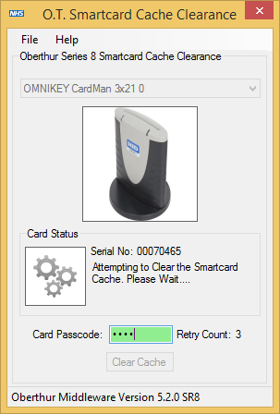

#### Successful Cache Clearance

When the Cache Clearance Tool has completed successfully, the user is given a green Thumbs Up picture. The user should now be able to authenticate with their Series 8 Smartcard without requiring a visit to the RA for a replacement Smartcard, assuming there are no other issues with the Smartcard operations in the target environment.

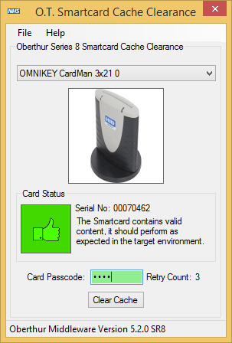

#### Unsuccessful Cache Clearance

If the Cache Clearance Tool fails to clear the cache, or the expected content of the Smartcard cannot be determined, the user is again presented with a red Thumbs Down picture and advised to see their RA to attempt to either repair or replace the Smartcard.

**NOTE**: A blank Smartcard will show the same indications and symptoms as a faulty Smartcard as the tool will be unable to read the expected Smartcard content and even though the cache will have been cleared, it will of course fail to validate the expected content on the card for to its blank state.

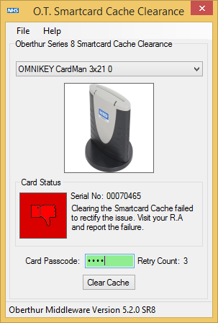

# Further Information

#### Incorrect Passcode Entry

The Cache Clearance Tool uses the users Smartcard Passcode to validate the content on the Smartcard.

**NOTE:** If the user enters their Passcode incorrectly three times into the tool, their Smartcard will be locked in the same way as three incorrect entries will do with Identity Agent, be mindful of this when using the tool.

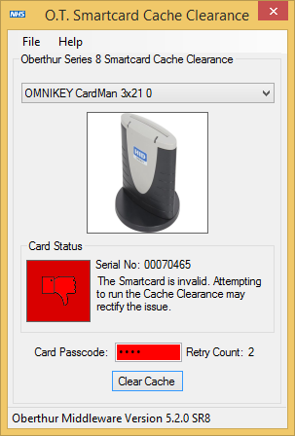

If the user has exhausted the retry count, the tool will show a blocked Smartcard Passcode as shown below.

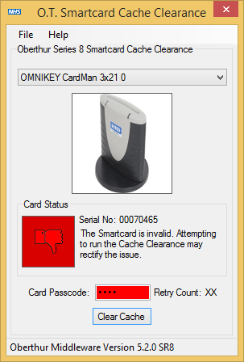

#### GEM only machine

The Cache Clearance Tool will only work on machines with Oberthur Middleware installed, this can be any installed version (SR1, SR5 or SR8). However, at the time of writing this document it is recommended that all machines that have SR1 or SR5 Middleware installed should be upgraded to SR8 due to the known issues in these Middleware versions, also SR1 and SR5 will be blocked from performing any CMS operations when CMS 2.4.0 is released in early 2019.

If the user tries to run the tool on a machine with only GEM middleware, they will receive the popup message below.

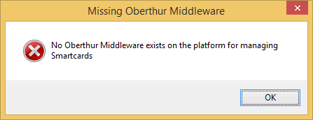

#### Oberthur Middleware Error

The Cache Clearance Tool will only work on machines with Oberthur Middleware installed and configured to manage the Series 8 Smartcard. This should not be an issue for any system which have used the NHS Digital installers for SR5 or SR8. However, if the user has installed SR1 this required the installation of both the middleware and a separate registry patch to be applied manually. If the registry patch has not been applied, or the user has uninstalled and then reinstalled GEM middleware without first removing the Oberthur middleware then the user will potentially encounter the following popup message below. This means that the target machine is in an unexpected state and the user should raise this issue with their support team.

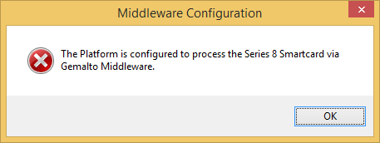

#### Multiple Smartcards and Card Readers

The Cache Clearance Tool supports the use of multiple Smartcard readers and Smartcards concurrently. Each Smartcard reader must have a Series 8 Smartcard inserted to be shown in the dropdown box. The application endeavours to retrieve an image for the supported Smartcard Reader type to help identify the Reader which contains the Smartcard they wish to process. Additionally, the application retrieves the Serial No for the Series 8 Smartcard which is located on the back-right hand corner of said Smartcard Series.

If you are still unsure of the Smartcard Reader you wish to work with, remove all Smartcards barring the single Series 8 Card you want to validate, and the tool will only show the one available Smartcard reader.

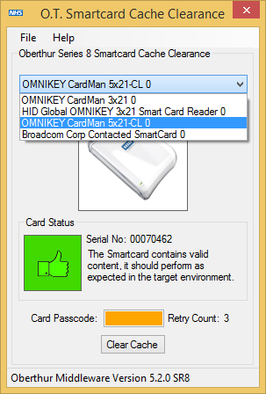

#### Smartcard Reader Identification

The Cache Clearance Tool will attempt to show the user a picture of identified Smartcard reader when a Series 8 Smartcard is inserted. If the Smartcard reader being used is not in the known database, the Cache Clearance tool will still work as normal, however the user will not be shown a picture of the reader type being used. Instead the picture box will report “No Image Available”.

If the user is unsure of the identification of the Smartcard readers in their machine, they should attempt to remove all Smartcards but for the single Series 8 Smartcard they wish to run cache clearance against.

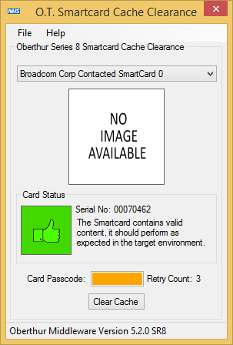

# Support

If you experience any problems with the application, you can raise an incident with the National Service Desk by emailing [enquires@nhsdigital.nhs.uk](mailto:enquires@nhsdigital.nhs.uk)

**Published by the Health and Social Care Information Centre**

For further information, feedback, and questions please visit:

<https://www.networks.nhs.uk/nhs-networks/identity-agent>

or sign up to our Slack channel:

[https://identityagent.slack.com](https://identityagent.slack.com/)

Copyright © 2019 Health and Social Care Information Centre. All rights reserved.

This work remains the sole and exclusive property of the Health and Social Care Information Centre and may only be reproduced where there is explicit reference to the ownership of the Health and Social Care Information Centre.

This work may be re-used by NHS and government organisations without permission.